Developed by Microsoft to overcome shortcomings of JS.

TS is built over JS, every JS file is a valid TS file.

# Advantages

* Statically typed & the type checking would happen at compile time. So we won't have to run our application and then run into errors.
* Code completion, Refactoring.

# Disadvantages

* Transpilation: TS has to be compiled into JS so that the browsers can understand.

src folder: we store our source code there + code get compiled on writing just tsc

dist folder: our transpiled JS code goes here

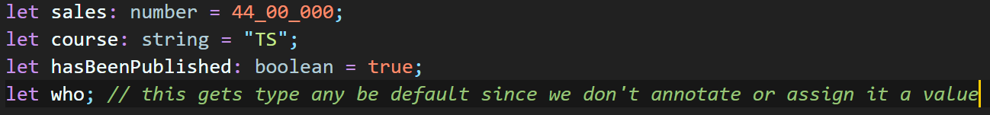

but we don’t want to use “any” as it defeats the purpose of using TS

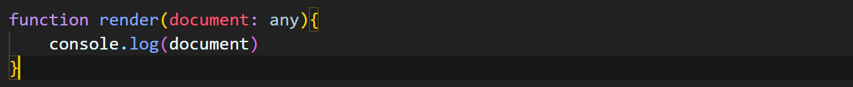

if we don’t want the error to be coming then either we can’t explicitly mention it to be any or change the tsconfig.json